

Green Problem #1: Shear Transformation

Background Information: In computer graphics, a shear transformation is a mapping that displaces each point in a fixed direction by an amount proportional to its signed distance from a given line parallel to that direction. For a point (x, y), a transformation in the x direction by a shear amount s returns a new point (x + sy, y).
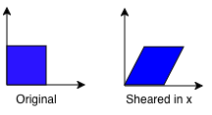
Given a point (x, y) and a shear value s, calculate the new point based on the shear transformation formula.

Programming Problem:
Input: Integers x, y, and s all on separate lines. Each integer input is in the interval [-1000, 1000].
Output: The new point based on the formula (x + sy, y), where x and y are separated by a single space.

Example 1: Input: Output:
2 2 1
1
0

Example 2: Input: Output:
3 4 -1
-1
-1

Example 3: Input: Output:
-2 1 3
3
1

