
35th Annual High School Programming Contest
Sponsored by | 

March 31, 2023

Green Problem #1: Rectangle Counting

Background Information:
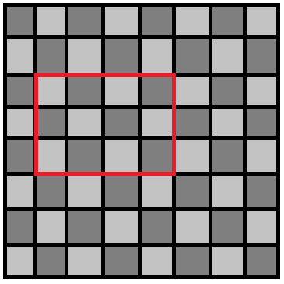
The number of unique rectangles that can be identified in an 8 by 8 checkerboard is 1,296. There are various ways to enumerate the rectangles. While counting the rectangles in a standard 8 by 8 checkerboard is an interesting problem, even more interesting is counting the number in an N by N checkerboard.
The more general problem may be approached inductively as follows:
There is 1 rectangle in a 1 by 1 checkerboard.

There are 9 rectangles in a 2 by 2 checkerboard.
There are 36 rectangles in a 3 by 3 checkerboard.
There are 100 rectangles in a 4 by 4 checkerboard.

You may notice that 1 = (1 x 2 / 2)²
and 9 = (2 x 3 / 2)²
Example of 3x4 rectangle in a 8x8 Checkerboard
and 36 = (3 x 4 / 2)²
and 100 = (4 x 5 / 2)²
and so you may conjecture that the number of rectangles in an N by N checkerboard is (N x (N + 1) / 2)² and you would be correct.

Write a program that inputs N, the size of your checkerboard and outputs the number of rectangles.

Programming Problem:
Input: A positive integer N < 256 representing the size of the checkerboard
Output: The number of rectangles in an N by N checkerboard

Example 1: Input: 3

Output: 36

Example 2: Input: 5

Output: 225

Example 3: Input: 10
Output: 3025

